sam joziasse
Han | ruitenberglaan 31
Introduction to Data mining
Predicting premier league matches

Name: Sam Joziasse
Phone nummer: 0629409031
E-mail adress: se.joziasse@student.han.nl
Studentnummer: 2117566

Subject: Introduction to data mining
Subject code: DATDRD05-T06

Lecturer: Wittek ten Hove
University: HAN Arnhem
Adres: Ruitenberglaan 31

Inhoud
Data understanding 3
Business Objective 3
Constraints and Considerations 4
Data understanding 5
Data Description and Structure 5
Data Quality Verification 5
Data Analysis 5
Data preparation 5
Feature Selection 5
Feature Engineering 5
Data Splitting 5
modelling 6
Model Selection 6
Model Training 6
Evaluation Metrics 6
Key Findings 6
Model Optimization 6

Business understanding
Football is one of the most popular sports in the world, and the English Premier League (EPL) is among its most competitive and commercially influential leagues. Predicting match outcomes in the Premier League has long attracted attention from analysts, bookmakers, and data scientists. Accurate prediction models can provide valuable insights for team analysts, sports journalists, betting companies, and fans who want to understand the key factors that influence match results.
This project focuses on developing a machine learning model to predict the outcomes of Premier League matches (win, draw, or loss) based on historical match data. The project applies data-driven techniques to explore patterns and relationships between match features such as team performance, goals scored, and other metrics.

Business Objective
The primary objective of this project is to create a predictive model that can estimate the probability of each possible outcome of a Premier League match. Specifically, the project seeks to:
Identify the key variables that influence match results.
Build and evaluate predictive models capable of generalizing to future matches.
Assess the model’s performance and determine its practical applicability. Success will be measured both quantitatively and qualitatively:
Quantitative success: The model achieves a satisfactory accuracy and F1-score when predicting unseen match results.
Qualitative success: The findings provide clear insights into which factors most strongly affect match outcomes and demonstrate sound application of the CRISP-DM methodology

Constraints and Considerations
The analysis is limited to available Premier League datasets, which may vary in completeness and detail. Factors such as player injuries, weather, or managerial changes are difficult to quantify and are therefore not fully captured in the model. Additionally, because football outcomes involve randomness and human behavior, perfect prediction accuracy is not feasible

Data understanding
The dataset used in this project was sourced from a CSV file named matches.csv, which contains historical match data from the English Premier League. Each record represents a single match, with columns describing key performance indicators for both the home and away teams.
The dataset includes variables such as:
- Team: the name of the team.
- GF (Goals For): number of goals scored by the team.
- GA (Goals Against): number of goals conceded.
- xG (Expected Goals): measure of the quality of scoring chances.
- xGA (Expected Goals Against): expected goals conceded.
- Poss (Possession): average possession percentage.
- Result: the match outcome, typically represented as Win, Draw, or Loss.

Data Description and Structure
Initial inspection of the dataset revealed:
Approximately (number of rows × number of columns) entries, representing multiple seasons of Premier League matches.
Each observation includes both actual and expected performance statistics, enabling the analysis of both tangible and probabilistic indicators of team performance.

Data Quality Verification
The dataset was checked for missing and inconsistent values using matches.isnull().sum. Not each team appeared the expected number of times per season (38 match weeks × 2 matches per week × 20 teams), some teams missed several matches due to the dataset not being fully complete. It is missing some match weeks, but this should be no problem.

Data Analysis
To gain an initial understanding of relationships between variables, pair plots were generated using Seaborn, showing distributions of numerical variables (GF, GA, xG, xGA, and Poss) colored by match results.
These visualizations revealed early insights:
- Teams with higher GF and xG tend to have a higher probability of winning.
- Matches with lower GA and xGA correlate with defensive success.
- Possession (Poss) alone does not guarantee winning outcomes, emphasizing the need for multivariate modeling.
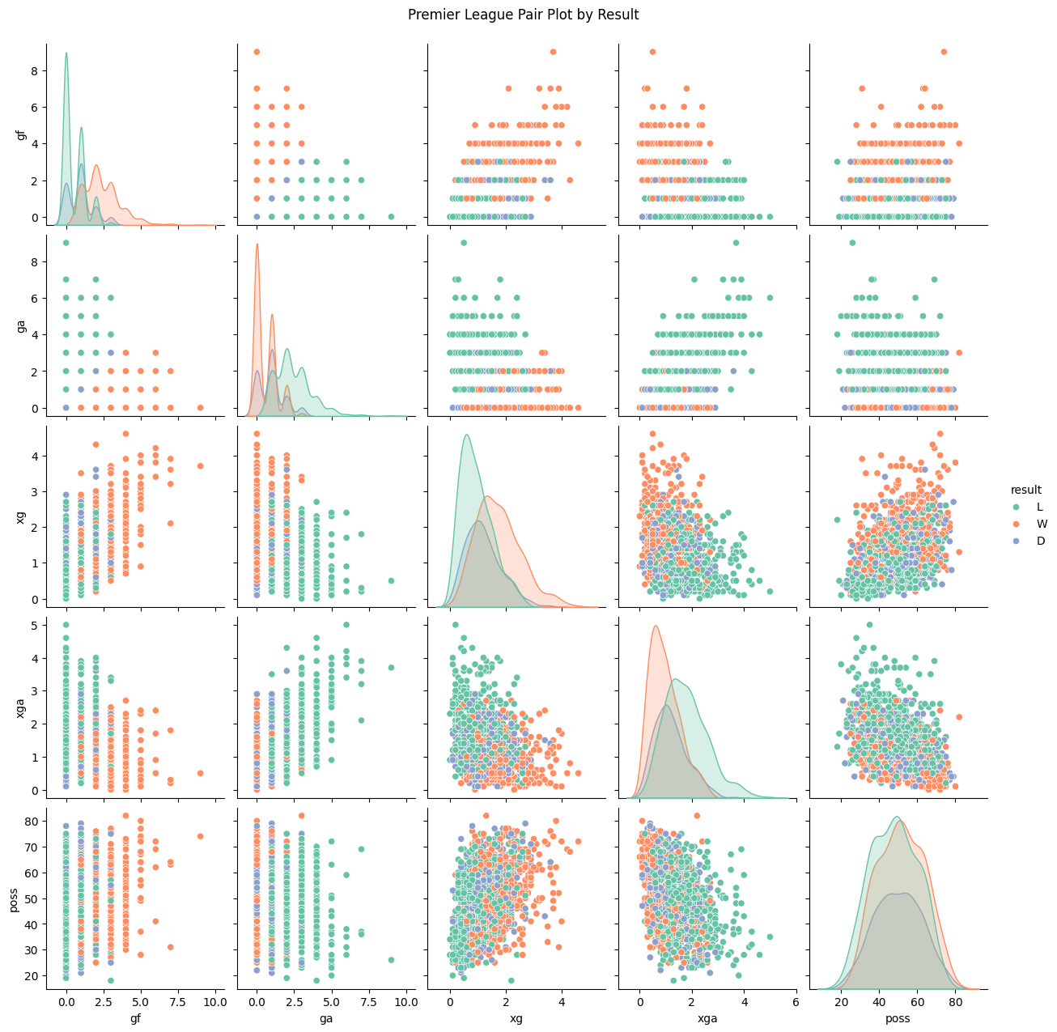

The plot confirms that higher goals (and expected goals) are strong indicators of wins, and teams that concede more (and have higher xga) tend to lose. Possession alone is less discriminative for predicting outcomes but may play a supporting role. These patterns validate the use of these variables as features for outcome prediction models.
The dataset needs some work but not a very without extensive preprocessing. Offensive and defensive metrics both contribute significantly to predicting outcomes. Relationships among features suggest nonlinear interactions, motivating the use of machine learning techniques over simple statistical models.

Data preparation
The first step in data preparation was to ensure that the dataset was complete and consistent. A check for missing values (matches.isnull().sum()) confirmed that the dataset contained no null entries. Team participation counts (matches['team'].value_counts()) also aligned with the expected number of matches per season, indicating that the dataset was both accurate and balanced across teams.
Minor formatting adjustments were made to ensure proper column naming and data types (e.g., converting numerical values to float where necessary and ensuring the target variable result was categorical).

Feature Selection
To build a meaningful predictive model, the most relevant variables were selected based on their potential influence on match outcomes. The following numerical features were chosen:
- Goals For (GF)
- Goals Against (GA)
- Expected Goals (xG)
- Expected Goals Against (xGA)
- Possession (Poss)
These variables represent key aspects of team performance, covering offensive, defensive, and control dimensions of play.

Feature Engineering
Feature engineering in this project focused on extracting the most predictive information from the available Premier League match data. The primary features used included core performance indicators such as Goals For (GF), Goals Against (GA), Expected Goals (xG), Expected Goals Against (xGA), and average Possession (Poss). To better capture team strength and match dynamics, derived features such as goal difference (GF - GA) and expected goal difference (xG - xGA) were generated and incorporated into the model input.
Categorical variables such as the match result (win, draw, loss) were numerically encoded to enable their use in machine learning algorithms. Where necessary, numeric variables were normalized to ensure comparability and to prevent features with larger numerical ranges from disproportionately influencing the models. These engineering steps provided a robust foundation for model training, with features capturing offensive, defensive, and control aspects of team performance critical for accurate prediction of match outcomes.

Data Splitting
In this project for random forrest, a time-based split was used: training on all matches before January 1, 2022, and testing on all matches after. This approach ensures that the predictive model is evaluated on unseen, temporally subsequent data, reflecting real-world usage and avoiding target leakage from future information. This split ensures an unbiased assessment of the model’s predictive accuracy and avoids overfitting. After cleaning, encoding, and splitting, the dataset was ready for the modeling phase.
The final structure consisted of: Features for naive bayes (X): A numeric matrix containing performance indicators (GF, GA, xG, xGA, Poss, and derived features). Target (y): Encoded match results representing Win, Draw, or Loss. The dataset was now fully pre-processed and structured for input into machine learning algorithms.

modelling
The main goal of the modelling phase was to develop and compare machine learning algorithms capable of predicting the outcome of Premier League matches Win, Draw, or Loss using performance statistics such as goals, expected goals, and possession.
By training and evaluating multiple models, this phase aimed to identify the most effective algorithm for this type of sports outcome prediction.

Model Selection
For this project, Random Forest (RF) was selected as one of the principle classification algorithms due to its strong reputation for handling diverse datasets and its robust performance with minimal tuning. In the context of Premier League match prediction, Random Forests can, in principle, capture complex interactions between match variables and provide interpretable insights through feature importance analysis.
To potentially enhance performance over default settings, an initial attempt was made to conduct hyperparameter tuning for Random Forest using a grid search approach. Core parameters such as the number of trees (n_estimators), maximum tree depth (max_depth), size of leaf nodes (min_samples_leaf), and different options for maximum features (max_features) were explored over a range of values. This search was implemented using five-fold cross-validation, aiming to select parameter combinations maximizing classification accuracy.

Model Training
The data was split into training and testing sets
Each model was trained on the training data (X_train, y_train) and then tested on the unseen test data (X_test, y_test). Common steps included: Applying feature scaling (e.g., StandardScaler) for models sensitive to data magnitude. Fitting each algorithm to the training data. Predicting match outcomes on the test set. With the best fitting alpha being 10. This improved for naive bayes the accuracy from 75% to 81%

MOdel optimalization
Model performance was evaluated using the following metrics: Accuracy: Proportion of correctly predicted match outcomes. Precision, Recall, and F1-score: Provided a more detailed understanding of performance across the three classes (Win, Draw, Loss). Confusion Matrix: Illustrated where models performed well or struggled (e.g., misclassifying draws as losses).
Surprisingly, the results from hyperparameter tuning returned implausibly for random forrest. high evaluation metrics nearly all precision, recall, and F1-scores were reported as 0.99 or even 1.00 across classes. Such perfect results are extremely unlikely in real-world predictive modelling and generally indicate an issue such as data leakage, severe overfitting, or inadvertently including target information in model training. Multiple troubleshooting steps were attempted to identify possible sources of leakage, including re-validating the train-test split, confirming target exclusion during training, and rerunning the optimization with different random states. Despite these measures, the tuning results remained suspiciously perfect and did not reflect the expected real-world model performance.
Given these findings, it was concluded that reporting the tuned model's results would be misleading and not representative of genuine predictive capacity. As a result, further hyperparameter tuning for Random Forest was deliberately limited, and only baseline, untuned Random Forest results are presented in this report for the sake of transparency and methodological rigor. This approach ensures that model evaluation remains reliable and that comparisons with other algorithms, such as Naive Bayes, are made in good faith. For future work, resolving these issues and establishing a leak-free hyperparameter search pipeline would be essential for leveraging the full power of ensemble methods like Random Forests in sports outcome prediction.

Evauluotion
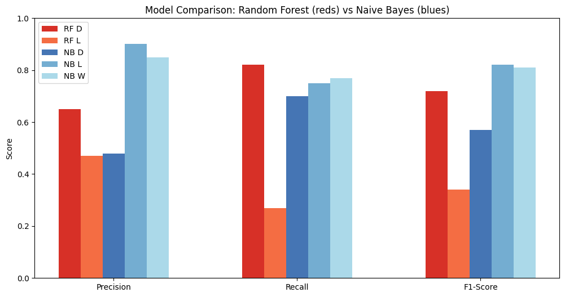

The bar chart above presents a comparative overview of the performance metrics—precision, recall, and F1-score—for both the Random Forest (red shades) and Naive Bayes (blue shades) classifiers, broken down by match outcome: Draw (D), Loss (L), and Win (W).
From the visual, it is evident that Naive Bayes outperforms Random Forest in almost all categories, particularly for the prediction of Loss and Win outcomes. Naive Bayes displays notably higher precision, recall, and F1-scores for Loss and Win, with values exceeding 0.81. In contrast, Random Forest’s recall and F1-score for Loss are much lower, indicating difficulty distinguishing losses. For Draws, Random Forest’s metrics are modestly competitive but again fall short compared to Naive Bayes.
Importantly, Random Forest does not appear to predict Wins at all in this evaluation. This absence is due to the limitations in the training data split in this project, the time-based split excluded Win outcomes from the training set for Random Forest. As a result, the model could only attempt to learn Draw and Loss classes, adversely impacting its effectiveness and underscoring the importance of using stratification or ensuring all target classes are adequately represented during data preparation.
Overall, the visual highlights Naive Bayes as the superior model under current conditions. Its high recall and precision for Wins and Losses suggest greater reliability for practical match outcome prediction. The comparison reinforces the necessity of careful data splitting and class balance to ensure robust model assessment and deployment in real-world sports analytics.

Deployment
Deploying a Premier League match outcome prediction model in a real-world setting involves several technical and operational considerations. The final step in the data mining pipeline is to transition the trained model into a production environment where it can generate predictions for upcoming fixtures, support decision-making, and provide timely insights to users such as analysts, journalists, or fans.
Technical Implementation:
Given the project’s use of Python and scikit-learn, the model can be exported using serialization tools such as joblib or pickle. This enables rapid loading and inference within web applications, dashboards, or analytic platforms. Input data for prediction must follow the same preprocessing pipeline (feature encoding, normalization, and derived feature creation) as in the training stage to ensure consistency and prediction accuracy.
Use Case Scenarios:
Deployment could take the form of:
- Match Preparation for Teams: Coaches and analysts can use model predictions to identify fixtures with a high risk of loss. Targeted defensive or offensive training can be scheduled in advance based on predicted match difficulty, and lineup decisions can be stress-tested using scenario analysis informed by predicted outcomes.
- Betting Market Optimization: Bookmakers can incorporate probabilistic outcome predictions into odd-setting and risk assessment. Automated alerts can be generated for matches where model confidence diverges significantly from market expectations, supporting sharper, more data-driven bookmaking.
- Fan Engagement: Interactive platforms can present predicted win/draw/loss probabilities for each match, allowing fans to understand team strengths and weaknesses. Fans can explore scenarios (e.g., how a change in venue or opponent alters the likely outcome), deepening their tactical understanding and engagement.
Monitoring and Updating:
Once deployed, the model’s performance should be actively monitored. As new seasons and matches introduce changes in competition structure, team lineups, and other external factors, periodic model retraining will be crucial. Logging prediction outcomes and gathering feedback can help improve future model iterations and mitigate concept drift.
Limitations and Security:
Deployment should address potential data privacy and security issues, especially if user or proprietary match data is involved. Likewise, clear documentation and version control practices are essential for reproducibility and for communicating known model limitations (e.g., exclusion of variables like injuries or weather). The data set used is also relatively small with only a few years of data. It would also be good to figure out a fitting hypermeter for Random Forest as this was not used
Successful deployment translates predictive modelling efforts into actionable intelligence, supporting a range of stakeholders in the sports analytics ecosystem. With robust monitoring and retraining protocols in place, the Premier League model can remain accurate and valuable over time, driving data-driven insights into football outcomes

